YEAR 8

KS3 MOCK EXAM REVISION BOOKLET

HISTORY

1. Harriet Tubman
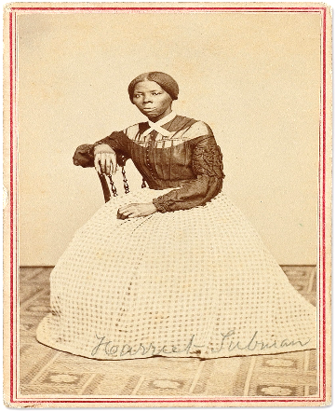
1. Harriet Tubman was born in Maryland, USA in 1820 on a slave plantation. She had 8 brothers and sisters. Most of her family were forced apart.
2. At the age of 12 Harriet had a taste for justice. She saw a slave owner about to throw a large rock at a slave. Harriet stood in its path and was hit in the head. She would suffer with sever headaches for the rest of her life.
3. In 1849, Harriet escaped with her brothers Ben and Henry. Ben and Henry changed their minds and went back but Harriet continued north.
4. Harriet used the ‘Underground Railroad’. This was code and not actually a train. Slaves would follow secret routes and sleep in safe houses until they reached Canada and freedom.
5. Harriet wanted to free her family and other slaves. She became a ‘Conductor’. This was code for someone that helped slaves along the secret route to Canada.
6. Harriet believed she saved 70 people from slavery but some reports go as high as 300.
7. When the Civil War broke out in 1861, Harriet became a nurse and treated many sick soldiers. She also helped free slaves in the army.
8. In 1869 Harriet married Nelson Davies and they went on to adopt a little girl named Gertie.
9. Harriet died in 1913 but her legacy lives on today. Throughout the United States, schools and museums have her name. Her story is told in books, movies and documentaries.

Task 1: Highlight the 4 best things Harriet Tubman did.
Task 2: Explain the 4 highlighted facts. Why were these things important? Or Good? (Use PEEL paragraphs - Point, Evidence, Explain and Link.
1. ______________________________________________________________________________________________________
________________________________________________________________________________________________________________________________________________________________________________________________________________________________________________________________________________________________________________________________________________________________________________________________________________________________2. ______________________________________________________________________________________________________
________________________________________________________________________________________________________________________________________________________________________________________________________________________________________________________________________________________________________________________________________________________________________________________________________________________________________________________________________________________________________________________________________3. ______________________________________________________________________________________________________
________________________________________________________________________________________________________________________________________________________________________________________________________________________________________________________________________________________________________________________________________________________________________________________________________________________________4. ______________________________________________________________________________________________________
________________________________________________________________________________________________________________________________________________________________________________________________________________________________________________________________________________________________________________________________________________________________________________________________________________________________________________________________________________________________________________________________________________________________________________________________________________________________________________________________________________________________________________________________________________________
2. WW1 (1914-1918): War Heroes – William Coltman and Flora Sandes
WILLIAM COLTMAN (1891-1974) | FLORA SANDES (1876-1956)
- He refused to kill a man because of his religious faith but still signed up to join the army in 1915.  - He worked as a stretcher-bearer. He would help wounded men make their way to a doctor.  - He rescued an officer shot in the leg. He ran out with his stretcher with no gun whilst being shot at.  - He saved many men that were wounded in no-mans-land.  - He organised a rescue party to save men buried alive in a bombed trench. | - She worked as a nurse helping wounded soldiers in Serbia.  - She worked with a Serbian regiment on the front line.  - She was the only British woman to officially fight in WW1 when the Serbian Army let her join.  - She was badly injured fighting and was awarded a bravery medal by the Serbian government.  - Even after her injuries, she went back to fight until the end of the war.
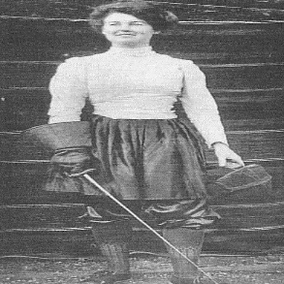
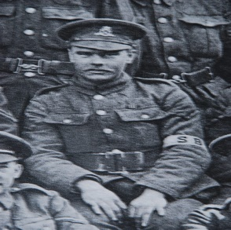
Task 1: Highlight the most important thing William Coltman AND Flora Sandes did.
Task 2: Explain the 2 highlighted facts. Why were these things important? (Use PEEL paragraphs - Point, Evidence, Explain and Link.
Para 1
________________________________________________________________________________________________________________________________________________________________________________________________________________________________________________________________________________________________________________________________________________________________________________________________________________________________________________________________________________________________________________________________________________________________________________________________________________________________________________________________________________________________________________________________________________________________________________________________________________________________________________________________________________________________________________________________________________________________________
Para 2
________________________________________________________________________________________________________________________________________________________________________________________________________________________________________________________________________________________________________________________________________________________________________________________________________________________________________________________________________________________________________________________________________________________________________________________________________________________________________________________________________________________________________________________________________________________________________________________________________________________________________________________________________________________________________________________________________________________________________
Task 3: Explain who you think is the most important hero. William Coltman or Flora Sandes.
________________________________________________________________________________________________________________________________________________________________________________________________________________________________________________________________________________________________________________________________________________________________________________________________________________________________________________________________________________________________________________________________________________________________________________________________________________________________________________________________________________________________________________________________________________________________________________________________________________________________________________________________________________________________________________________________________________________________________
3. Women during WW2
1. ‘WAAF’: Women’s Auxiliary Air Force  Lilian Bader is believed to be the first black woman to join the British army. In 1941 she joined the WAAF (Women’s Auxiliary Air Force). The WAAF repaired RAF planes and worked on radar to spot enemy planes. | 2. ‘ATS’: Auxiliary Territorial Service  British women were not allowed to fight but joined the ‘Auxiliary Territorial Service’ or ‘ATS’. They would search the skies for enemy aircraft with spotlights. | 3. ‘WI’: Women’s Institute  Member of the ‘Women’s Institute’ organised activities such as country walks and tea parties for evacuee children in the countryside.
4. ‘WLA’: Women’s Land Army  80,000 women joined the ‘Women’s Land Army’. They worked very hard for long hours. The women who worked on farms were known as ‘Land Girls’. The farms would help feed Britain and the troops at war. | 5. Women in factories  Millions of women chose to work in factories producing ammunition, uniforms, weapons, and even airplanes. They worked for many hours each day, and many decided to live closer to the factories. | 6. Women Code Breakers  Joan Clarke was a British woman that worked in Bletchley Park. She studied maths at Cambridge University. Alan Turin, Joan Clarke and others broke secret German codes and messages.
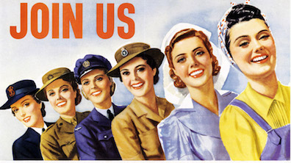
Task 1: Highlight the best 3 things women did during WW2.

Task 2: Explain the 3 highlighted facts. Why are these important. (PEEL paragraph - Point, Evidence, Explain and Link).
Para 1
________________________________________________________________________________________________________________________________________________________________________________________________________________________________________________________________________________________________________________________________________________________________________________________________________________________________________________________________________________________________________________________________________________________________________________________________________________________________________________________________________________________________________________________________________________________________________________________________________________________________________________________________
Para 2
________________________________________________________________________________________________________________________________________________________________________________________________________________________________________________________________________________________________________________________________________________________________________________________________________________________________________________________________________________________________________________________________________________________________________________________________________________________________________________________________________________________________________________________________________________________________________________________________________________________________________________________________
Para 3
________________________________________________________________________________________________________________________________________________________________________________________________________________________________________________________________________________________________________________________________________________________________________________________________________________________________________________________________________________________________________________________________________________________________________________________________________________________________________________________________________________________________________________________________________________________________________________________________________________________________________________________________

4: WW1 trench conditions
1. When there was no fighting, life in trenches was boring. | 2. Sleeping was uncomfortable and difficult. | 3. Sentries (men at guard) feared being shot by snipers. | 4. At night men had to go into No Man’s Land to fix barbed wire & recover the wounded.
5. There was a shortage of food and the menu was usually the same every day (beef, a biscuit and jam). | 6. There were not many places to wash so many men had lice. They would burn lice eggs every night from their clothes. | 7. The sewage system and rotting dead bodies created a terrible smell. | 8. Rats fed on the dead bodies. They could carry diseases into the trenches.
9. Living in fear and constant shelling caused mental health problems. This was known as Shell Shock. | 10. Standing in dirty water caused ‘Trench Foot’ (feet swell). 75,000 men had it and some had to be amputated (cut off) | 11. Shell holes filled with water and could drown soldiers if they fell in. | 12. Disease and illness could easily spread. Typhoid was a common disease.
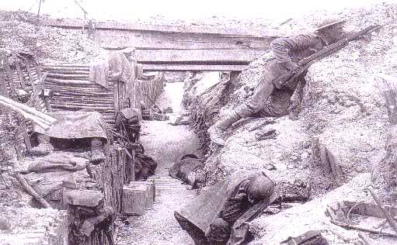
Task 1: Decide which conditions are the worst. Rank the above conditions from worst (1st= worst, 2nd, 3rd etc.)
Task 2: Highlight the 3 worst conditions in WW1 trenches.
Task 3: Explain the 3 highlighted conditions. Why are they bad? (Use PEEL paragraphs - Point, Evidence, Explain and Link.
Para 1
________________________________________________________________________________________________________________________________________________________________________________________________________________________________________________________________________________________________________________________________________________________________________________________________________________________________________________________________________________________________________________________________________________________________________________________________________________________________________________________________________________________________________________________________________________________________________________________________________________________________________________________________
Para 2
________________________________________________________________________________________________________________________________________________________________________________________________________________________________________________________________________________________________________________________________________________________________________________________________________________________________________________________________________________________________________________________________________________________________________________________________________________________________________________________________________________________________________________________________________________________________________________________________________________________________________________________________
Para 3
________________________________________________________________________________________________________________________________________________________________________________________________________________________________________________________________________________________________________________________________________________________________________________________________________________________________________________________________________________________________________________________________________________________________________________________________________________________________________________________________________________________________________________________________________________________________________________________________________________________________________________________________

