Academic Year 2021 – 2022

Science Department Curriculum

Remote Learning Plan – Schemes of Learning Overview

KS4 Science
Students will follow the sequence of the online textbook from AQA answering questions as they go. Each lesson they will be assigned a task for the pages used from that lesson.
Kerboodle:

- In the search bar type in www.kerboodle.com
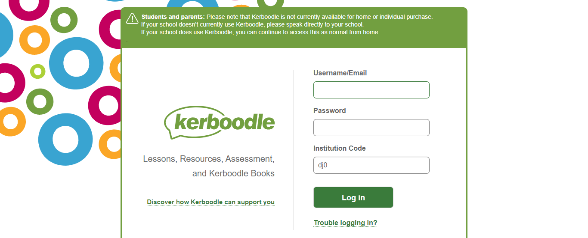

Username: your first initial and second name i.e Dave Smith = dsmith
Password – default password = your usename i.e dsmith but then after logging in you can change your password.
Institute code- dj0
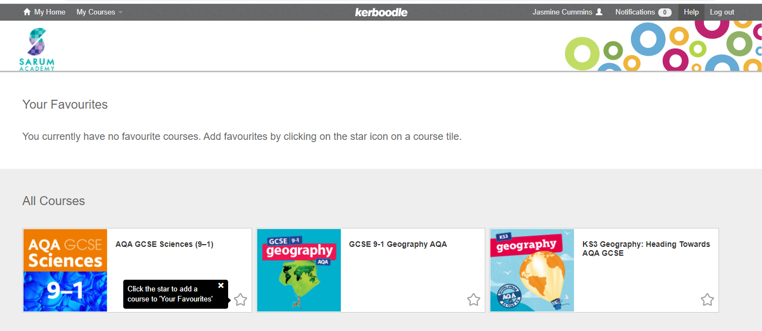
- Select the course you are doing [AQA GCSE Sciences (9-1)]
- Select digital book

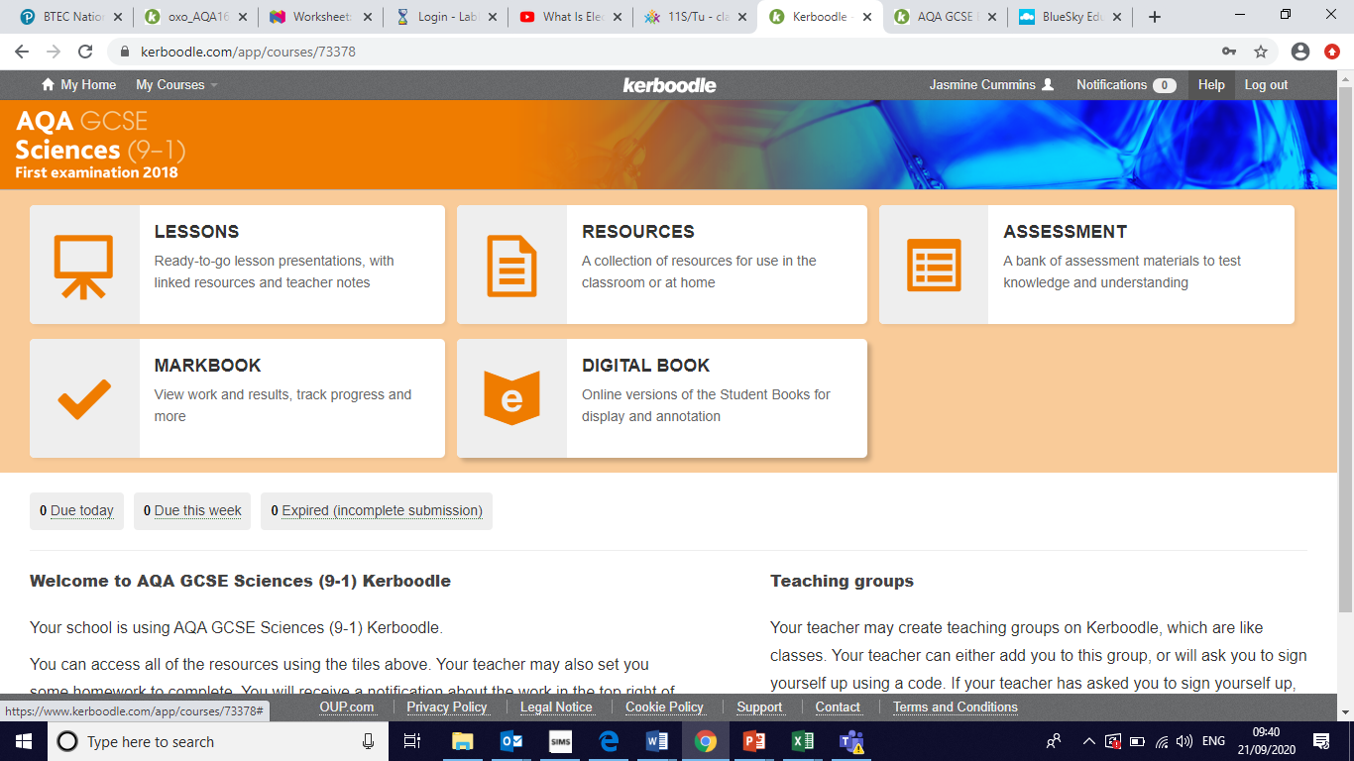

- Select the following books
- Biology Combined Sciences text book: Trilogy
or
Physics Combined Sciences text book: Trilogy
Or
Chemistry Combined Sciences text book: Trilogy

BBC Bitesize for KS4 Science has been linked. Oak National Academy has also been linked, which has video lessons and assessments for reviewing student knowledge.
On the 4 lesson of each week students will be given a topic on Tassomai to complete with a minimum of 25 questions and 55% correct answers target.
Year 11:
Term | Unit | Core Content | Links
1 | Physics: PARTICLE MODEL | Density, particles, internal energy, changes of state, specific heat capacity, Brownian motion | Textbook Physics for combined science P70-95  https://classroom.thenational.academy/units/particle-model-of-matter-a6d5  https://www.bbc.co.uk/bitesize/topics/z3ybb82
 | Chemistry: ENERGY CHANGES | Energy stores, exothermic reactions, endothermic reactions, reaction profiles | Textbook Chemistry for combined science 96-105  https://classroom.thenational.academy/units/energy-changes-b607  https://www.bbc.co.uk/bitesize/topics/z27xxfr
 | Chemistry: QUANTITATIVE CHEMISTRY | Relative formula mass, conservation of mass, thermal decomposition, the mole, balancing equations | Textbook Chemistry for combined science 56-65  https://classroom.thenational.academy/units/quantitative-chemistry-4db7  https://www.bbc.co.uk/bitesize/topics/zsnyy4j
2 | Chemistry: ORGANIC CHEMISTRY | Hydrocarbons, alkanes, alkenes, cracking, fractional distillation | Textbook Chemistry for combined science 128-137  https://classroom.thenational.academy/units/organic-chemistry-7c58  https://www.bbc.co.uk/bitesize/topics/z9488mn
 | Chemistry: USING EARTH’S RESOURCES | Finite resources, renewable resources, potable water, waste water management, recycling | Textbook Chemistry for combined science P160-173  https://classroom.thenational.academy/units/using-resources-febe  https://www.bbc.co.uk/bitesize/topics/zptnng8
 | Biology: ECOLOGY | Communities and competition, interdependence, biotic factors, abiotic factors, adaptations, sampling ecosystems, carbon cycle, water cycle, biodiversity, waste management, land use, deforestation, global warming | Text book Biology for combined science 204-245  https://classroom.thenational.academy/units/ecology-a6da  https://www.bbc.co.uk/bitesize/topics/zxxhh39
3 | Chemistry: CHEMICAL ANALYSIS | Purity, formulations, gas tests, flame tests, chromatography | Textbook Chemistry for combined science 138-147  https://classroom.thenational.academy/units/chemical-analysis-cf8d  https://www.bbc.co.uk/bitesize/topics/zgbccj6
 | Physics: WAVES | Transverse waves, longitudinal waves, frequency, wave speed, electromagnetic spectrum, uses of EM waves, dangers of EM waves | Textbook Physics for combined science P134-157  https://classroom.thenational.academy/units/waves-4cef  https://www.bbc.co.uk/bitesize/topics/z2j22nb
 | Physics: MAGNETISM | Magnetic fields, electromagnetism, induced magnets | Textbook Physics for combined science P158-165  https://classroom.thenational.academy/units/magnetism-bf8d  https://www.bbc.co.uk/bitesize/topics/zwkww6f
4 and beyond | GCSE Revision  Completion of GCSE Combined Science exams [B1, B2, C1, C2, P1, P2]  B1 & B2:  https://classroom.thenational.academy/subjects-by-key-stage/key-stage-4/subjects/biology  https://www.bbc.co.uk/bitesize/topics/zthssrd  C1 & C2:  https://classroom.thenational.academy/subjects-by-key-stage/key-stage-4/subjects/chemistry  https://www.bbc.co.uk/bitesize/topics/z88jjty  P1 & P2:  https://classroom.thenational.academy/subjects-by-key-stage/key-stage-4/subjects/physics  https://www.bbc.co.uk/bitesize/topics/zqw77p3

