NORMAN ENGLAND,
1066AD – 1100AD,
KNOWLEDGE BOOKLET

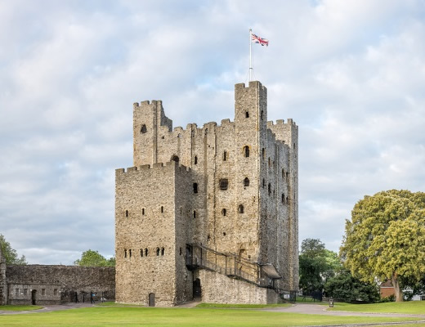
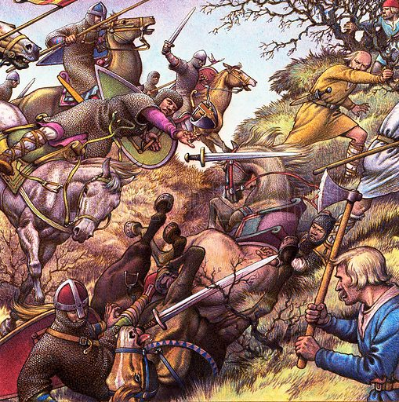
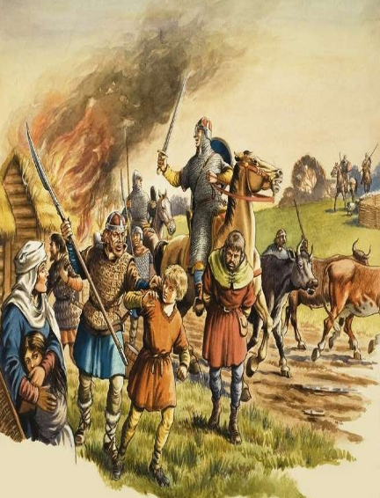

CONQUEST & CONTROL

1. CAUSES OF THE NORMAN CONQUEST

ANGLO-SAXON ENGLAND BEFORE 1066:
- EDWARD THE CONFESSOR ruled 2 MILLION Anglo-Saxons from 1042-1066. Before Edward, England was ruled by a Viking called HARTHACNUT.
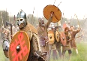
- England had TRADED with Viking countries but Edward grew up in Normandy (France) so traded with them instead.
- England was organised into a HIERARCHY (King, Earls, Thegns, Peasants).
- England was also not well defended. The Anglo-Saxons DID NOT HAVE MANY CASTLES and was often raided by Vikings.
- The king was helped by POWERFUL EARLS who owned lots of land. The GODWIN family were the most powerful family in England.
- In 1052 King Edward and earl Godwin had a DISAGREEMENT. Godwin was kicked out of England but came back with a large army. He apologised to King Edward and they both lived peacefully.
- England had 2500-3000 HOUSECARLS (professional soldiers) and huge peasant army called the FYRD.
- England had a MINTING SYSTEM which meant they could make coins. People were CATHOLIC CHRISTIANS which meant they were loyal to the Pope in Rome (2nd to God). Most of Southern England was covered in FORESTS OR FARMS.
DEATH OF A KING AND THE NEW CLAIMS:
- King Edward dies with NO SONS on 5th January 1066. Four men wanted to become the new King of England.
- HAROLD GODWINSON, son of Earl Godwin and an Anglo-Saxon, quickly becomes the NEW KING in January 1066 but faced opposition.
- To be king you had to be a RELATIVE, SON, or the king’s CHOICE. The WITAN had to support you. You could also take the throne by FORCE.
- King HAROLD GODWINSON was an Anglo-Saxon Earl of Wessex. He was sub regulus/deputy king and was an experienced soldier. He claimed Edward promised him the throne on his deathbed.
- Edgar The Outlaw was a 15-year-old Anglo-Saxon. He was the great-nephew of Edward but was treated like a son. Many earls supported him.
- HARALD HARDRADA was the Viking king of Norway. He was related to King Cnut of England (1016-35) and his dad Magnus was promised the throne in the 1040s. He was a famous warrior and had a huge army.
- WILLIAM OF NORMANDY had been Duke since he was 7. He was also Edward’s cousin & helped Edward fight a rebellion in 105. He believed Edward and Harold had promised him the throne.
VIKING INVASION:
- King HARALD HARDRADA sailed up the River Humber in North England with 300 SHIPS. His army landed 16 miles from the city of YORK.
- The BATTLE OF FULFORD GATE (20th Sep 1066) was between the Anglo-Saxon Earls Edwin & Morcar and Hardrada.
- Hardrada had 7000 Vikings but Anglo-Saxons had just 3500. After a bad start he VIKINGS WON battle. Edwin & Morcar fled.
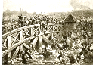
- King HAROLD heard about the defeat and MARCHED NORTH with a fresh army.
- The BATTLE OF STAMFORD BRIDGE (25th Sep 1066) was between King Harold Godwinson and Hardrada.
- Harold travelled 200 MILES in 4 days & waited in Tadcaster overnight. He took the Vikings by SURPRISE on Stamford Bridge.
- Many Vikings didn’t have their ARMOUR on and were SPLIT over the RIVER DERWENT.
- One Viking on Stamford Bridge slowed the Anglo-Saxons & killed 40 men. He was eventually killed and the Vikings were surrounded.
- Harold’s brother, TOSTIG, betrayed him and fought with the Vikings. Hardrada and Tostig were BOTH KILLED. 24/300 Viking ships fled home.
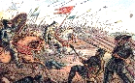
2. NORMAN MILITARY: BATTLE OF HASTINGS AND CASTLES

NORMAN INVASION:
- PREPARED: Normans sailed from RIVER SOMME (quicker) with FRENCH MERCENARIES (paid professional soldiers). A new NAVY was built to carry William’s soldiers, horses & ‘flat pack’ castles. KING PHILIP I supported William and the POPE gave him the PAPAL BANNER (God’s support).
- Normans landed in PEVENSEY ON 28TH SEPTEMBER but waited, rested and trained for the BATTLE OF HASTINGS ON THE 14TH OCTOBER (2 weeks).
- TACTICS: Normans had 7000 knights, archers & cavalry. the Anglo-Saxons had 7000 housecarls and peasants. the Normans used flags & horses to communicate. they used the ‘feigned retreat’ to trick the English to break apart the shield wall on top of Senlac Hill.
- MISTAKES: Anglo-Saxons were tired from Stamford Bridge, the Fyrd/peasant army was inexperienced, the shield wall was broken due to the feigned retreat trick, Harold knew about Williams tactics but didn’t prepare & didn’t wait to gather 30,000 Englishmen.
- LUCK: Normans were lucky that it was harvest time so many Englishmen not available to fight, the Vikings invaded first so weakened the English and bad weather delayed the Normans arrival so they had time to prepare in the South when Harold had to march back down.
- BATTLE: 9AM: battle starts & both sides do well12PM: break to collect dead, Shield wall strong & Normans move archersfeigned retreat breaks up shield wall & Normans attack on foot4PM: Shield wall breaks apart, Harold is killed (arrow through eye) & the Anglo-Saxons fled.
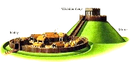
3. NORMANS TAKE CONTROL

WILLIAM TAKES CONTROL:
- After Battle of Hastings William controls TRADE/PORTS IN KENT. Then he controls the CHURCH IN CANTERBU RY. He then fights in LONDON and burns Southwark. After this he takes WINCHESTER WHICH CONTROLS ENGLAND’S MONEY/TREASURY. In November ARCHBISHOP STIGAND fails to make Edgar king. Stigand, Edgar, Edwin, Morcar then swear loyalty to William in BERKHAMPSTEAD. On Christmas 1066 William is crowned KING.
REBELLIONS:
- 1067: EDRIC the Wild, with English & Welsh allies, attacked the Welsh border. In 1069 he was defeated in Shrewsbury castle. In the same year, EUSTACE of Boulogne failed to take Dover castle (Kent). Edric and Eustace both made peace with William.
- 1068: William besieges EXETER city for 18 days till they surrender. He builds a castle & places his half-brother, ROBERT OF MORTAIN, in charge.
- 1069: HARRYING OF NORTH. A Norman, Robert of Commines, killed by the English. Edgar, Waltheof, Malcolm III, Vikings (240 ships) captured York castle. William bribed the Vikings to leave & had 80% of Yorkshire’s land BURNED. The land was SALTED so crops died and people starved.
- 1070: HEREWARD THE WAKE was angry the Normans took his dad’s land & killed his brother. He rebels & hides (guerrilla warfare) from William on the ISLAND OF ELY (marshy are in the fenlands of East Anglia). William built a 2-mile BRIDGE which sunk, had a WITCH in a tower cast spells (set on fire) but only defeats the rebels when MONKS showed him a secret route. Rebels were arrested but Hereward DISAPPEARED.
- 1070-72: KING MALCOM III OF SCOTLAND invades north, he is defeated, signs peace with William (Treaty ‘Abernethy’).
- 1075: NORMAN EARLS ROGER & RALPH REBEL & were helped by Earl Waltheof & King Philip of France. William asks Lanfranc & Odo (bishop & half-brother) to help him. Roger was put in prison, Ralph fled to France & the Anglo-Saxon, Waltheof, was beheaded.
CASTLES:
- Between 1066 and 1086, the Normans built 500 CASTLES to intimidate, patrol and rule areas across England.
- Castles were built to defend the Normans but over time they became places of business and law & order.
- Normans built MOTTE & BAILEY castles. They were normally built on geographical features like hills or by rivers.
- The first castle the Normans built was PEVENSEY CASTLE. This was built when the Normans invaded England on 28th September 1066.
- KEEP (strong building on top of hill/motte. Lord lived). MOTTE (hill for keep). BAILEY (area inside walls for houses). WALLS (wood/stone high walls to stop intruders). GATEWAY (Gatehouse had windows to shoot arrows. Some had drawbridges). MOAT (ditch or water surrounding walls).
- WILLIAM FITZOSBERN made ‘MARCHER LORD’ to protect the WELSH BORDER. He built castles on the border at Chepstow, Clifford & Monmouth.

LIFE UNDER THE NORMANS

1. FEUDALISM AND GOVERNMENT

FEUDAL SYSTEM (SOCIAL HIERARCHY)
- ANGLO-SAXON FEUDAL SYSTEM: King, Earl, Thegns/Housecarls and Peasants. Normans system: King, Earls & Church, Knights and Peasants.
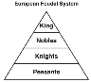
- Norman system: KING OWNS ALL LAND and gives some to CHURCH AND BARONS.
- Barons & Church gave some land to KNIGHTS (soldiers) who fight for them.
- The knights control the PEASANTS who have no land and work on farms to make food.
- Land for support is known as ‘PATRONAGE’. Land is called a ‘FIEF’. Land owners are ‘TENANTS-IN-CHIEF’.
- OLD EARLDOMS: Wessex, Northumbria, Mercia & East Anglia. NEW SMALLER EARLDOMS: Kent, Chester, Hereford & Norfolk.
- 250 people run all the land in England.
DOMESDAY BOOK (1085-1086)
- By 1085 William was WORRIED about VIKINGS and the Count of FLANDERS in France invading TAX (geld) was needed for MONEY & TROOPS.
- Domesday Book was a SURVEY/question book to check if lords paid their tax, how many men in England to fight & to check food for army.
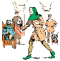
- Survey shows William owned 20% of land, Church 25%, 10 Normans held 25%, 170 men owned the last 30%.
- It also showed that out of the population of around 2 million only 2000 were Norman knights and 10,000 were Norman settlers.
LAW AND ORDER: COURTS
- Normans kept Anglo-Saxon courts but made some changes.
- Inheritance under Anglo-Saxons was split to family. The Normans used PRIMOGENITURE. They gave land to the eldest son (not split up).
- HUNDRED COURT run by deputy-sheriff dealt with local crime. SHIRE COURTS run by Sheriff dealt with serious cr ime (land, taxes & rebellions).
- The HONORIAL COURT replaced the Shire Court (people spoke issues with their lord).
- The KINGS COURT (King was judge). ECCLESIASTICAL COURT was the church’s own court.
- Normans used the Anglo-Saxon COMMON OATH where people promised to not commit crime (promise to God) but added MURDRUM FINES (whole town punished if Normans were attacked).
LAW AND ORDER: CRIME
- Trial by ordeals used horrid methods to prove if someone was guilty. It was down to GOD to show them if a person was GUILTY OR INNOCENT.
- TRIAL BY FIRE: held hot iron or put hand in boiling water. If arm wasn’t healed after 3 days, the person was guilty.
- TRIAL BY WATER: tied up & thrown in lake. If they drowned they were innocent (but died). If they floated they were guilty and were executed.
- TRIAL BY COMBAT: (Normans law) Noblemen accused of a crime would fight the person accusing them. The winner was innocent.
- FOREST LAWS banned hunting in King’s forests. If caught people were fined, mutilated (blinded) or executed.
- LAWS (Writs) in were written in Latin.
WHO KILLED WILLIAM II (WILLIAM RUFUS) IN 1100?
- ROBERT was the oldest brother & was angry that William II was made King and not him. In 1088 he rebelled against his brother but failed.
- HENRY was the younger brother & was angry that he was given £5000 and no land. He became King of England as soon as William II died.
- WALTER TIREL shot William when hunting and ran to France. His family (Giffards) and wife’s family (Clares) were given lots of money & lands.
- PEOPLE OF ENGLAND were treat harshly by William II. They had unfair taxes and hated William listened to a small group of advisors.
- SCOTLAND tried to rebel in 1091 but William II defeated them. At Battle of Alnwick in 1093 William kills King Malcom of Scotland.
- CHURCH had many disagreements with William II. Archbishop Anselm ran away to Rome and his lands were taken by William.

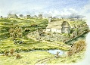
2. SOCIETY AND ECONOMY (MONEY)

NORMAN VILLAGE:
- 90% of people lived in a village and there were 13,400 villages by 1086.
- STONE CHURCH in middle of villag e for weddings, funerals, defence (if no castle), food storage, bell for work timings and even prison.
- NORMAN LORDS owned a manor house & land (demesne). The Lord owned the village, woods, lakes, barns, houses, farms & crops.
- A MANOR was an area that included the manor house, church and farmland. Peasant had to have Lord’s permission to leave.
- Fields were divided into strips called the OPEN FIELD SYSTEM. Each strip was run by a peasant who could grow grain, vegetables or herbs.
- FALLOW LAND was land left alone for a few years so the soil could recover to grow crops in the future.
- CRUCK HOUSE: dirty hut for peasants made from mud, sticks & straw. They were cold, small and even had animals. Families lived in 1 room.
- Wharram Percy was a famous Anglo-Saxon village near York discovered by archaeologists.
- A REEVE was a peasant (chosen by the lord) who managed the other peasants. A BAILIFF collected tax/crops for the king. A MILLER used the Lord’s oven to make bread (Lord made money by deciding price).
NORMAN PEASANTS:
- Peasants WORKED on the farms 6 days a week & spent Sunday at church. They had some Holy Days off work (this became the word holiday).
- Sometimes there was ENTERTAINMENT: wrestling match, shin-kicking, cock fights, travelling musicians or even a bear entertainer.
- In SPRING seeds were planted. In SUMMER crops were harvested & collected. In AUTUMN land was prepared by Ox ploughing the land. In WINTER peasants couldn’t farm but had to try and stay alive.
- PEASANTS ATE rye bread for lunch & vegetables for dinner. They didn’t eat meat or sugar (too expensive). They drank homemade beer.
- LORD’S ATE meat and fish every day. They even ate cakes and pastries.
- FREEMEN were higher level peasants. VILLEINS were lower level peasants. Villeins did more for the lord than freemen.
- Peasants’ payed the Norman lord RENT, paid TAXES to king.
- Peasants paid another tax to the church called a TITHE. The Tithe was 10% of their money or goods. The church stored it all in a TITHE BARN.
- LITTLE MONEY was left over and peasants still had to pay for seeds for the following year. They generally struggled to survive.
NORMAN TOWN
- TOWNS GREW: London was the largest with 10,000. Winchester had 6000. Norwich, York and Lincoln had 5000. The Normans made 21 TOWNS.
- A BURGESS was a high ranking BUSINESSMEN. They worked with lord, handles law and traded property. More burgesses meant more money.
- WOOL, for clothes, was made in the countryside & traded in market towns like York & Lincoln. Wool was then traded abroad to BELGIUM.
- Trading ABROAD meant towns on the COAST grew (London, Southampton). Bristol traded English wool for French WINE.
- DROITWICH town had 13 Salt houses that made SALT. Salt can be used in cooking and preserving food so it last longer.
- GLOUCESTER was near the Forest of Dean and used wood for METALWORK. Metal was sold or used for weapons and housing.
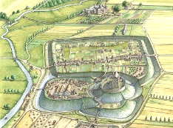
- The king gave out 2800 GRANTS. Grants meant towns could hold markets. MARKETS were places to buy and sell goods.
- FAIRS were also held in towns. They were religious events of celebrations. This brought more traders and entertainers which made money.
- Burgesses could be CRAFTSMEN: goldsmith, leatherworker, bakers and shopkeeper. They joined together to create powerful GUILDS.

THE NORMAN CHURCH

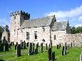
1. THE CHURCH

NORMANS AND RELIGION
- Normans (like Anglo-Saxons) were CATHOLIC CHRISTIANS & believed in heaven & hell. The Church was led by the Pope.
- LATIN was th e language of the church. People COULDN’T READ so used pictures/windows/drawings to understand.
- The Church was RICH and powerful. They owned 25% of the land & collected 10% TITHE tax. The church COURT handled legal issues & crimes.
- Churchmen were politically powerful men that could INFLUENCE THE KING.
- The church copied BOOKS and were well educated. Most SCHOOLING/EDUCATION was offered by churchmen.
- Priests held church serv ices such as confession, weddings, funerals, baptisms and helped the sick. They influenced local people.
WILLIAM’S CHANGES TO THE ENGLISH CHURCH (REFORMS)
- Normans changed/updated the English church to keep POPE Leo and Pope Gregory happy (powerful ally).
- BATTLE ABBEY was built on site of Battle of Hastings and huge CATHEDRALS were built in Winchester, Durham & Rochester.
- William sorted problems in the English church. CELIBACY: priests stopped marrying/ having children. PLURALISM: priests only allowed one job. SIMONY: priests can’t sell powerful jobs in church. NEPOTISM: priests can’t give church jobs to friends/family. This kept Pope and God happy.
ARCHBISHOP LANFRANC AND WILLIAM’S CHANGES TO THE CHURCH
- Anglo-Saxon Bishops like Archbishop Stigand were REPLACED WITH NORMANS like Lanfranc. By 1096 all top church jobs were held by Normans.
- New abbeys/cathedrals like Durham, Rochester, Winchester, Bath & Gloucester were built in the ROMANESQUE STYLE (clean lines & arches).
- The Church was organised better. Big areas called DIOCESE were divided into ARCHDEACONRIES. These were then divided into DEANERIES.
- 1076 COUNCIL OF WINCHESTER set up Church Courts. Only the church could try a churchman for a crime. POWER OF THE CHURCH RISES.
NORMANS AND THE POPE
- After Battle of Hastings POPE ALEXANDER II ORDERED William to do PENANCE for the killing. William built Battle Abbey on the battlefield.
- William I and William II gave JOBS IN THE CHURCH to men that supported them. This ANGERED THE POPE and England’s Archbishop, Anselm.
- William I and II TOOK MONEY/GOLD FROM CHURCHES. A Norman monk melted gold ornament from Abingdon church worth £35,000.
- When Archbishop LANFRANC DIED in 1089, William II STOLE HIS LANDS and didn’t create a new archbishop.
- After getting ill (scared that god was punishing him) William II replaced Lanfranc with ANSELM in 1093. William & Anselm ARGUED for years.
- POPE GREGORY reforms 1070-1085: wanted priests to follow STRICT RULEs. He also wanted the church to be FREE FROM KINGS CONTROL.

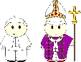
2. MONASTICISM

DURHAM CATHEDRAL
- Built in the ROMANESQUE STYLE: big, stone, round arches, clean style and shape of a cross. Built to keep Pope happy.
- The BISHOP OF DURHAM became PRINCE OF DURHAM and was given lots of POWER TO DEFEND THE NORTH of England against Scotland and Malcom III in 1075 onwards.
- The cathedral also intimidated and scared people to not rebel against the Normans.
- The SHRINE (REMAINS) OF ST. CUTHBERT was kept by the Normans. This meant people travelled to Durham making it rich. It also won support as he was a popular Anglo-Saxon saint.
MONKS & MONASTICISM (MONK’S WAY OF LIFE)
- William wanted BENEDICTINE MONKS to come to England to win the Pope’s support. The POPE WAS A POWERFUL ALLY!
- Monks made BENEDICTINE VOWS: CHASTITY: monks could not have sex. POVERTY: monks gave up possessions. OBEDIENCE: monks obey god and the abbot/abbess. STABILITY: Monks would never leave the church.
- Life of a monk meant living in isolation, growing their own food, constantly praying, copy old books (medical books) in scriptoriums, help the sick, work in almonries to raise money for poor, teach local people and even advise the king.
- The Cluniac order were a strict group of French Benedictine monks in Cluny.
- William wanted Cluny monks to come to England in 1077.
- After refusing, Earl WILLIAM DE WARRENE, persuaded 3 MONKS to come to England. They set up a priory outside his castle (1078-1082).
- By 1100 there were 36 CLUNIAC MONASTERIES in England. This meant the Pope would support the Normans. The POPE WAS A POWERFUL ALLY!
- After 1066 Monks in England grew to 5000 by 1135 and religious houses went from 60 to 250.
EDUCATION
- Normans moved schools from churches and Monasteries and into the growing CITIES AND TOWNS.
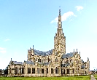
- KNIGHTS AND BARONS wanted their children to be educated for future jobs.
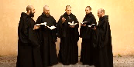
- School year started in SEPTEMBER and ended in JUNE (Summer off for peasants to collect HARVEST).
- Townspeople needed better literacy and numeracy for TRADE.
- By 1100 there were 40 schools (French was spoken but LATIN was used to read and write).
- Archbishop LANFRANC and ANSELM both helped promote schools and built LIBRARIES.
- At 10 years old some pupils went to GRAMMAR schools (Exeter, Lincoln, Northampton & Oxford). Taught Latin at school and later at UNIVERSITY.

REVISION TASKS

Revision Task 1: Create quiz questions using the information. Test yourself.
Hint: Only create questions to information you don’t know.

e.g.
 | QUESTION | ANSWER
1. | Who is the best teacher in Sarum? | Mr Miller or Mr Gale
2. | What is the best subject in Sarum? | History

Revision Task 2: Highlight the key information in the revision booklet in 3 colours (Is it EASY, MEDIUM or HARD to remember).
Hint: Do not highlight the whole sentence. Focus on names, events, dates etc.

e.g.
e.g. 1 Mr Miller and Mr Gale are the best teachers ever.
e.g. 2 History is the best subject ever.

Revision Task 3: Create a mind-map of a category. For example, ‘Medieval Public Health’, ‘Renaissance Surgery’ or ‘1800s ideas’.
Hint: Summarise the bullet points in your chosen category rather than copy them.

e.g.
Reasons why History is the best

Revision Task 4: Summarise the Medieval, Renaissance or 1800 period in just key words.
Hint: Write 1-50 on a piece of paper. Try to write down 50 key words for an entire unit.

e.g.
Miller | Gale | History | Best
Subject | Exciting | Interesting | Fun

Revision Task 5: Memory game. Read one unit, e.g. Medieval. Once you have read the page, without looking, write down as many facts as you can remember.
Hint: When you have done, use a different colour to add facts you didn’t remember. Repeat and see how much more you do.
e.g.
Look | Cover | Write | Check

