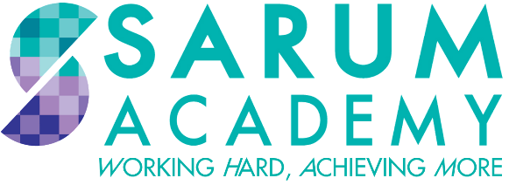

BRITAIN,
HEALTH AND THE PEOPLE,
1000AD – 1800s,
MOCK EXAM BOOKLET

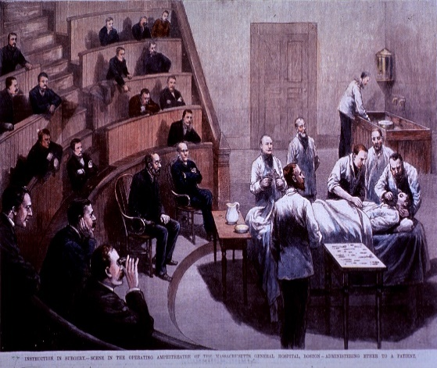
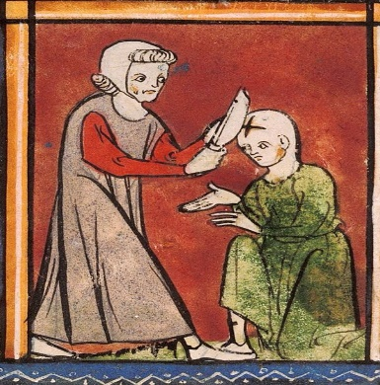

MEDIEVAL MEDICINE

IDEAS

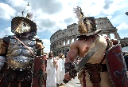
- HIPPOCRATES (460-370 BC) was an ancient Greek. He believed people were sick because their FOUR HUMOURS (Yellow bile, Black bile, phlegm & blood) were not balanced. He wrote many books about observation, diet & rest.
- GALEN (130-210AD) was an ancient Roman. He also believed in the ‘Four humours’. He worked with gladiators & learned about injuries. He also DISSECTED animals to learn about humans (not the same!). The church liked his ideas so made sure they lasted for hundreds of years.
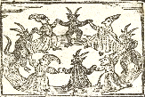
- People DID NOT know about germs or how disease was caused. People believed sickness was caused by God (sins), bad smells, supernatural (witches/demons) and the Four Humours. None of these cause illness.
- The church controlled UNIVERSITIES in England so made doctors use old ideas to help sick people.
- People went on PILGRIMAGES or ‘religious trips’ to churches or graves like St John of Bridlington’s.
- The Church had a scientist called ROGER BACON arrested in 1277 for doing new research and not trusting old ideas like Galen.

TREATMENTS

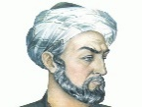
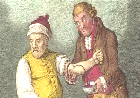
- ISLAMIC medicine was the best in the medieval period. They had medical books & hospitals included BAGHDAD & CAIRO.
- AVICENNA was an Islamic doctor. Avicenna wrote the CANON OF MEDICINE in 1020AD which was printed many times in Europe & contained much medical knowledge. Avicenna’s books influenced doctors till 1700.
- RHAZES was another Islamic doctor who wrote over 150 books.
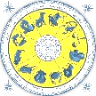
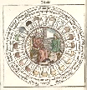
- Doctors used the Four Humours to find cures & believed illness was caused by a humour in the body NOT BEING BALANCED. For example, leeches were used to suck out ‘bad blood’. This was called BLOODLETTING and did not work.
- Doctors could also use the pulse or a URINE CHART (colour, smell and taste) to decide what plant or herb they would use to treat an ill person. A ZODIAC CHART used the stars to help a doctor decide a treatment. This also did not work. It took a doctor 7 years to TRAIN AT UNIVERSITY.
- An APOTHECARY sold medicines (Simples =1 herb & Compounds = mixture). A WISE WOMAN gave basic cures or acted as a midwife.

SURGERY
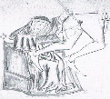
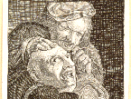
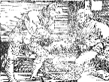
- BARBER SURGEON carried out basic operations AND even cut hair. AMPUTATION was common (cutting off limbs).
- ALCOHOL could be used to help with the pain but mostly people were held down. OPIUM (heroin) could be used as an ANAESTHETIC (pain killer) but it could also kill. If someone was bleeding a surgeon would use CAUTERISATION which is a hot piece of metal to seal the wound.
- JOHN ARDERNE was a famous English surgeon. He had experience in the Hundred Year War with France. He used opium to numb the pain. He had a 50% survival rate REMOVING LUMPS from a person’s anus (common in knights). In 1350 his book Practice of Surgery told doctors to trust their ideas not Galen. He also treated the poor for free and charged the rich.
- HUGH OF LUCA AND HIS SON THEODORIC were Italians. They stopped putting puss into wounds and instead used wine which reduced infections. They also created a tool to pull out arrows.

PUBLIC HEALTH

- Most towns were built by RIVERS for people to get their water. As towns grew in size they became very dirty.
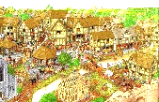
- Rivers were used for drinking and washing water but also for getting rid of HUMAN WASTE (wee & poo!).
- There were basic toilets in some places called PRIVIES. Privies were outdoor toilets with a hole or CESSPIT. The hole was full of waste & had to be collected otherwise it could overflow into the street.
- Buildings were CRAMPED and many people lived in small areas which meant disease could spread quickly.
- Councils didn’t want to RAISE TAXES and anger people which meant the problems couldn’t be fixed.
- Animal waste and businesses also POLLUTED rivers with waste and chemicals. Rules on safe food didn’t exist.
- In 1421 COVENTRY COUNCIL wanted streets to be cleaned on Saturdays, waste to be collected & set up specific rubbish areas.
- The church built over 700 HOSPITALS in the medieval period such as St Bartholomew Hospital for pregnant women, St Mary of Bethlehem for people with mental issues and St. Giles for the sick. St Giles built the church so he could get to heaven.

PUBLIC HEALTH – MONASTERIES

- MONASTERIES are large churches where monks and nuns live. Monasteries had very good public health compared to the towns.
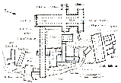
- The church had lots of MONEY which is why they could improve their public health.
- Monasteries collected safe water, REDIRECTED RIVERS to wash away waste, BUILT WATER PIPES, had wash rooms called ‘LAVATORIUMS’, built privies which were regularly emptied and had baths for keeping clean.
- MONKS were educated and read medical books. Monks would grow medical herbs in a PHYSIC GARDEN and kept away from towns which helped them avoid diseases. Monks believed keeping clean was another task to keep God happy.

PUBLIC HEALTH – THE BLACK DEATH

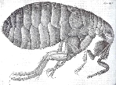
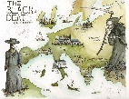
- The BLACK DEATH in 1348 killed 50-66% of England or at least 1.5 million people.
- The Black Death was the BUBONIC PLAGUE (spread by fleas, caused black puss filled buboes on the groin, neck and armpits and people would vomit blood) and the PNEUMONIC PLAGUE (spread by breath or blood, was more deadly, infected lungs, caused extreme fever & coughing).
- People thought the Black Death was CAUSED by Planets, Earthquakes, the Four Humours, God and some blamed Jewish people.
- The Black Death was actually SPREAD by rats in dirty towns. Fleas would infect the rats which then spread to humans. People lived/worked close together so spread the illness. People died quickly due to a lack of good food in many areas.
- People would POP lumps, strap CHICKENS to their armpits, drink vinegar or FLAGELLATION (people whipped themselves). People would also pray, burn candles in church, avoid sex & food, carry sweet herbs for ‘bad smells’ & have a bath in URINE (some drank it!!).
- The Black Death caused FOOD SHORTAGES as farmers died and food rotted in the fields. Farmers changed to sheep farming as it required less people so less food was made. Less food meant prices went up. People starved!
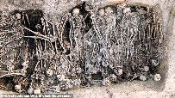
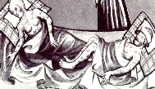
- The Black Death led to WAGE RISES as peasants could move to different villages and farms for more money. The government stopped this by making a law called the STATUTUE OF LABOURERS in 1351.
- The Black Death also DAMAGED THE IMAGE OF THE CHURCH as it couldn’t protect the people.

RENAISSANCE MEDICINE

IDEAS

- Renaissance means ‘REBIRTH’. Ancient Greek and Roman scientific ideas became popular. People read old books and found mistakes.
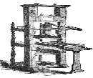
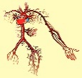
- People began asking questions & thinking differently. This led to a ‘SCIENTIFIC METHOD’ of experiments & discovery.
- The PRINTING PRESS was made in the 1451 which meant books could be printed quickly and cheaply. More medical books were made leading to more knowledge being learned across Europe.
- Leonardo da Vinci studied the human body & DREW ACCURATE PICTURES which were more realistic.
- ANDREAS VESALIUS dissected humans to understand the body. His book ‘DE HUMANI CORPORIS FABRICA’ in 1543 showed the inside of the human body. Accurate drawings helped surgeons and changed people’s opinions about old ideas, especially Galen.
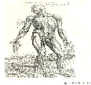
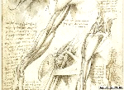
- Vesalius’ work was copied by THOMAS GEMINUS and was sold all across England. English barber surgeons now had better knowledge of the human body.
- WILLIAM HARVEY’S experiments proved the heart pumped blood around the body in a one-way system (CIRCULATIO N). This proved Galen wrong. Galen thought the liver made blood which is wrong. Harvey published his book, ‘ON MOTION OF THE HEART’ in 1628.
- Some refused to accept William Harvey’s ideas about the blood and it took 50 years before PARIS UNIVERSITY taught them. It wasn’t until 1901 (hundreds of years later) that this knowledge could be used in modern day surgery.

TREATMENTS

- An APOTHECARY sold medicines (Simples =1 herb & Compounds = mixture). A WISE WOMAN gave basic cures or acted as a midwife.
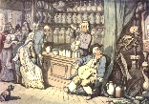
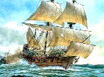
- LADY JOHANNA ST JOHN (1600s) made a recipe book of cures in her manor house ‘Lydiard House’.
NICHOLAS CULPEPPER’S book the Complete Herbal in 1653 gave advice about herbs and plants.
- During the 1600s and 1700s QUACK DOCTORS would travel to towns selling fake medicines. DAFFY’S ELIXIR (1647) for example was made of random ingredients (brandy and seeds).
- EXPLORERS sailed around the world and brought back new ingredients for medicines. CINCHONA BARK from South America treated malaria. OPIUM from Turkey & helped numb pain (heroin!!). TOBACCO from N.America and was wrongly used.
- THOMAS SYDENHAM (1624-89) Believed in observation, exercise and understanding the symptoms (scientific method). He used cinchona bark to treat malaria and ‘Cool therapy’ to keep patients cool when treating smallpox.
- SMALLPOX killed 30% of people that caught it. INOCULATION was used to help. Puss from smallpox victims was rubbed into a person and it helped them become immune. However, inoculation was EXPENSIVE AND DANGEROUS.
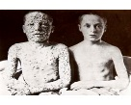
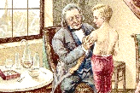
- EDWARD JENNER heard rumours that milkmaids that had cowpox (less deadly version) didn’t catch smallpox.
- Edward Jenner experimented on JAMES PHIPPS (9-year-old) in 1797 by giving him cowpox sand then smallpox. The boy survived. He proved cowpox made people immune to smallpox. In 1798 he published ‘CAUSES AND EFFECTS OF VARIOAE VACCINAE’.
- At FIRST EDWARD JENNER’S VACCINATION WAS NOT ACCEPTED. He didn’t know about germs so couldn’t prove his ideas. Other doctors were worried about missing out on inoculation money. Jenner was a country doctor so city doctors didn’t take him seriously (snobs!).
- In 1802 the GOVERNMENT gave him £10,000 for research. Mixed reaction.
- Smallpox vaccination was given to children for free in 1840, COMPULSORY in 1853 and parents fined in 1871. Smallpox reduced massively after 1870s. LAST CASE WAS IN 1977.

SURGERY

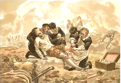
- BARBER SURGEONS were still available but were still poorly trained and could perform basic operations or cut hair.
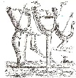
- AMBROISE PARE was an army surgeon. He ran out of boiling hot oil to cauterise patients wounds (seal them by burning the wound). Instead, Pare used a herb mixture of ROSE OIL, EGGS AND TURPENTINE. The mixture healed the wound better than pouring boiling oil.
- When amputating a limb Pare used LIGATURES to tie off blood arteries to stop the bleeding. Ligatures were small stitches. Ligatures worked better than cauterising the limb (burning it).
- Ambroise Pare also make FAKE LIMBS for soldiers that lost them in war. Many of his ideas were printed in his book ‘LES OEUVRES’, 1575.
- Many English surgeons read Pare and Vesalius’ books to help them improve. WILLIAM CLOWES was an English surgeon to Queen Elizabeth I. William Clowes used Pares ideas of stopping bleeding. In 1588 he made his own book called ‘PROVED PRACTICE’.
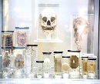
- In 1720, WILLIAM CHESELDEN (St Thomas Hospital, London) removed stone from bladder in 1 minute. SPEED was important due to no pain relief. Opium & alcohol was used but an incorrect dose could kill.
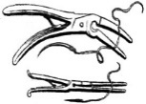
- JOHN HUNTER (1728-93) was a British army surgeon and teacher of anatomy (human body). He DISSECTED BODIES to discover new ideas about disease, infections, cancer and blood circulation.
- Hunter even EXPERIMENTED ON HIMSELF. He gave himself gonorrhoea but also syphilis by mistake (STDS!)
- John Hunter used experiments to prove how to save a man’s leg. He tied off blood arteries and helped blood flow properly.
- John Hunter collected human body parts and SPECIMENS (7-foot-tall skeleton) & was of burking (stealing dead bodies to dissect and learn)
- Hunter wrote books: ‘NATURAL HISTORY OF TEETH’, ‘VENEREAL DISEASE’ and ‘BLOOD AND GUNSHOT WOUNDS’.

PUBLIC HEALTH

- Henry VIII changed England’s religion so the CHURCH HAD LESS CONTROL OF HOSPITALS. He paid for St Bartholomew’s & St Thomas’ in London.
- In the 1700s PRIVATE PEOPLE PAID FOR HOSPITALS. Westminster was founded by a bank and Guy’s hospital was founded by a businessman.
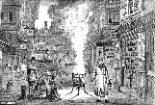
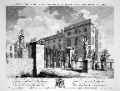
- Between 1720-50 five new hospitals were built that helped 20,000 PATIENTS A YEAR in London.
- In 1741 THOMAS CORAM created the FOUNDLING HOSPITAL.
- The Foundling Hospital took in ABANDONED BABIES and gave them foster families. Children aged 5-15 would be trained for service in homes or the army. Abandoned children were so common a lottery system was used to enter.
- The 1665 PLAGUE KILLED 100,000 people in London.
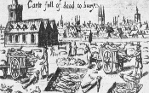
- People thought the Plague was CAUSED by bad smells (miasma), planets, earthquakes, the Four Humours and God.
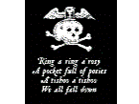
- People would POP lumps, strap CHICKENS to their armpits, drink vinegar or FLAGELLATION (people whipped themselves). People would also PRAY and carry sweet herbs to get rid of ‘BAD SMELLS’.
- There were some good methods to deal with the 1665 Plague. The Mayor of London and King introduced Preventions such as STOP PUBLIC EVENTS, no cats, dogs or pigs in the streets, rubbish was cleared, victims were locked in their houses and QUARANTINED (red cross above their door), bodies were taken regularly and buried in large pits pray and the border with Scotland closed.

1800s: INDUSTRIAL REVOLUTION MEDICINE

IDEAS
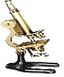
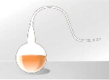
- The MICROSCOPE was invented in 1677 but it wasn’t until 1861 when doctors realised germs caused disease.
- Doctors believed in SPONTANEOUS GENERATION: the idea that germs and infections happened by magic.
- CONTAGIONISTS believed people spread diseases to each other & ANTI-CONTAGIONISTS believed disease was caused by the environment.
- In 1860 LOUIS PASTEUR discovered that Germs caused disease. His SWAN NECK FLASK EXPERIMENT showed germs made wine go stale.
- In 1866 a plague killed many cows causing food shortages. Professor LIONEL BEALE investigated and found it was a microbe or germ killing the cow. This proved Louis Pasteur’s Germ theory and made it more accepted in Britain.
- Professor CHARLES BASTION argued against Germ theory but in 1870 scientist JOHN TYNDALL argued for Germ Theory.
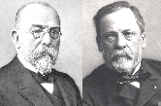
- ROBERT KOCH was a German doctor. He proved GERMS CAUSED DISEASES IN HUMANS which Louis Pasteur couldn’t do.
- Robert Koch STAINED GERMS using coloured dyes. He found DIFFERENT TYPES OF GERMS and their disease. He was able to GROW GERMS using seaweed and made it easier to PHOTOGRAPH them to study.
- WILLIAM ROBERTS helped doctors learn about germs. WILLIAM CHEYNE translated Robert Koch’s work into English.
- In 1871 German and France were at war. Pasteur was French and Koch German. They competed to find more about disease.
- Robert Koch found the germ that caused ANTHRAX (1876), TUBERCULOSIS or TB (1882) and in CHOLERA (1883).
- From 1879 to 1885 Louis Pasteur’s team proved how VACCINATIONS worked (like Edward Jenner’s). This led to new vaccines like RABIES.
- In 1909 PAUL EHRLICH created a MAGIC BULLET called Salvarsan 606. This targeted bad germs (Syphilis - STD) & didn’t harm the body.

TREATMENTS
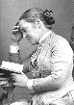
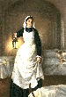
- Between 1853 to 1856 FLORENCE NIGHTINGALE was a nurse in the Crimean War. She cleaned hospitals and reduced deaths from 40% to 2%. She published Books Notes on Nursing and Notes on Hospitals (1863) that improved nurse care.
- In the 1870s Elizabeth Garrett and Sophia Jex-Blake FIRST FEMALE DOCTORS to treat patients.

SURGERY

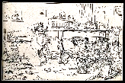
- Surgery was painful! Medieval pain killers or anaesthetics were still used like OPIUM AND ALCOHOL. Opium could kill if the wrong dose was given and alcohol made the heart beat faster which made the patient lose more blood!
- HUMPHRY DAVY published a paper about NITROUS OXIDE OR LAUGHING GAS to kill pain but it was never taken seriously.
- ROBERT LISTON copied Americans by using ETHER GAS to kill pain. It worked but made people vomit and was flammable.
- In 1847 IGNAZ SEMMELWEISS was in charge of a baby ward. He made all doctors wash their hands before treating patients. The death rate dropped from 35% to just 1%. He published his results but many didn’t believe it!!
- In 1847 JAMES SIMPSON found CHLOROFORM could be used for pain when a bottle was ACCIDENTALLY knocked over & put him to sleep.
- In 1848 a wrong dose of chloroform was given to a young girl called HANNAH GREENER. She died during a toenail operation.
- QUEEN VICTORIA used chloroform in 1853 when having a baby describing it as ‘soothing, quieting and delightful beyond measure’.
- However, INFECTIONS ROSE and more people died because no one knew about germs. Some doctors stopped using chloroform.
- JOSEPH LISTER read about Louis Pasteur and Germ Theory. He used a chemical called CARBOLIC ACID to kill germs and sterilise his surgeries.
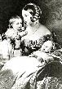
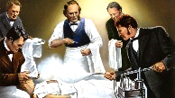
- In 1865 Joseph Lister used carbolic acid on a young boys broken leg. After 6 weeks JAMIE GREENLESS was able to walk without his leg being amputated. Lister began soaking bandages and ligatures with carbolic acid to fight infection.
- 1871 Joseph Lister used a MACHINE that automatically sprayed the room. Deaths went down from 46% to 15%. ‘ANTISEPTIC SURGERY’!
- Some British DOCTORS DISAGREED LISTER. They believed in old ideas, didn’t like being wrong & felt carbolic acid was messy.
- By the late 1800s antiseptics like Carbolic Acid were being used less and surgeons used ‘ASEPTIC METHODS’. Aseptic surgery is keeping germs away completely by cleaning a room and wearing protective equipment & clothes.
- In 1881 CHARLES CHAMBERLAND discovered STEAM could kill germs on medical tools (140° for 20 mins).
- BERKLEY MOYNIHAN became the first English surgeon to WEAR GLOVES & SURGICAL GOWNS as part of aseptic surgery.

PUBLIC HEALTH
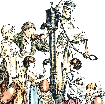
- Industrial Revolution saw CITIES GROW. People lived in horrid and overcrowded conditions. Back to back houses made disease spread quickly for working class people.
- Some houses had toilets but most people share. Waste would often be emptied in rivers and drinking water could get CONTAMINATED.
- CHOLERA AND TYPHOID were common diseases caused by contaminated water/food. Cholera killed 50,000 in 1831. This led to the government asking EDWIN CHADWICK to investigate.
- In 1842 Edwin Chadwick wrote a ‘REPORT ON THE SANITARY CONDITIONS OF THE LABOURING POPULATIONS’. He gave out 10,000 free copies and spoke with journalists and politicians. He wanted the government to keep streets and water clean and that poor people were not to blame for disease. Chadwick influenced the government to improve the living conditions (this even led to ‘The Clean Party’).
- In 1848 the government created the 1ST PUBLIC HEALTH ACT. This created a ‘Board of Health’ to hire medical officers who inspected houses, food, water and sewage. This WASN’T COMPULSORY and was expensive so many cities & towns refused.
- In 1848, 60,000 people died of cholera. In 185, 20,000 people died.
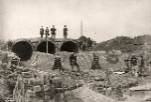
- In 1854, a London doctor called JOHN SNOW plotted 700 cholera deaths on a map. He noticed they appeared around a water pump on BROAD STREET. The pump was removed and the disease stopped. This proved water caused cholera and Snow believed it was because it had been contaminated by sewage (cesspit 1 meter away).
- In 1858 a hot summer made London stink. This was known as ‘THE GREAT STINK’. The government paid £3 million (£1 billion today) to JOSEPH BAZALGETTE to build a huge underground sewer from London to the sea. The 83 mile, 318 million brick sewer used gravity and a water pump at Crossness to move London’s waste (420 million gallons a day) to the sea.
- In 1875 THE 2ND PUBLIC HEALTH ACT meant medical officers checking food, sewers, sewage, fresh water and rubbish were COMPULSORY.

REVISION TASKS

Revision Task 1: Create quiz questions using the information. Test yourself.
Hint: Only create questions to information you don’t know.

e.g.
 | QUESTION | ANSWER
1. | Who is the best teacher in Sarum? | Mr Miller or Mr Gale
2. | What is the best subject in Sarum? | History

Revision Task 2: Highlight the key information in the revision booklet in 3 colours (Is it EASY, MEDIUM or HARD to remember).
Hint: Do not highlight the whole sentence. Focus on names, events, dates etc.

e.g.
e.g. 1 Mr Miller and Mr Gale are the best teachers ever.
e.g. 2 History is the best subject ever.

Revision Task 3: Create a mind-map of a category. For example, ‘Medieval Public Health’, ‘Renaissance Surgery’ or ‘1800s ideas’.
Hint: Summarise the bullet points in your chosen category rather than copy them.

e.g.
Reasons why History is the best

Revision Task 4: Summarise the Medieval, Renaissance or 1800 period in just key words.
Hint: Write 1-50 on a piece of paper. Try to write down 50 key words for an entire unit.

e.g.
Miller | Gale | History | Best
Subject | Exciting | Interesting | Fun

Revision Task 5: Memory game. Read one unit, e.g. Medieval. Once you have read the page, without looking, write down as many facts as you can remember.
Hint: When you have done, use a different colour to add facts you didn’t remember. Repeat and see how much more you do.
e.g.
Look | Cover | Write  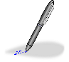 | Check

