17 September 2021

Dear Parents and Carers

RE: Set Changes Within Maths and Associated Subjects
We are writing to inform you that some changes are planned with regard to our Year 7 classes. Since we welcomed our new Year 7 cohort in September, to aid their transition to Secondary School they have been taught in their mixed ability tutor groups for all lessons. Now they are settled in and from Monday, 27th September certain subjects will be changed to be taught based on the pace students learn at, whereas others will remain as mixed ability classes. The changes will be as follows:

Maths Set (Pace) | English Set (Mixed)
Maths | English
Science | History
IT | RE
Music | Geography
PSHCE | Food Technology
PE | Design Technology
French | Art

We believe that grouping students based on the pace they learn for certain subjects ensures that the work will be accessible for all students in those lessons. We firmly believe that placing students in the class where the pace is right for them will enable all students to maximise their potential.
In normal circumstances we base the academic grouping on SATs results. Your child completed some assessments recently within Maths and you will have also received a letter about CAT tests. The purpose of all these assessments is to give us a clearer understanding of the capabilities of each student so we can best support your son/daughter. We will be collecting further data over the remainder of this term and will inform you if there are any further changes. New timetables will be printed and given to all students in due course, but you will also be able to see their timetable on ClassCharts.
If you have any concerns regarding these changes please do not hesitate to contact Mr Maddison, Head of Year 7, on the following e-mail address: robert.maddison@sarumacademy.org
Yours sincerely
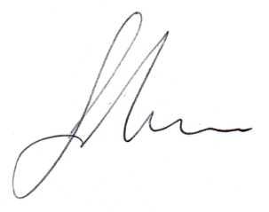
Mr Gareth Jones
Senior Leader Standards and Careers

