16th February 2022

Dear Parent
We hope this correspondence finds you well. Following on from last month’s letter, we are writing to update you on the latest information regarding summer 2022 exams.
Last week the examination boards published the adjustments that will be made to GCSE, AS and A level qualifications in summer 2022. The intention is to make sure that students are treated as fairly as possible, given the disruptions they have experienced due to Covid. These measures include; providing a choice of topics in some exams so that less content will be assessed and for most subjects, exam boards have also given advanced information about the content of the exams. This is designed to provide students with guidance on what to revise ahead of the summer exams. Some exams will also allow students access to support materials including formulae and equation sheets, so that students do not have to memorise as much. In addition, exams will be graded more generously this year providing a safety net for students.
All the relevant information for the summer 2022 examinations is available on our website in the examinations section.
https://www.sarumacademy.org/exam-information
Please be aware that advanced information might not look the same for all subjects because of how they are structured and how they are assessed. Your child’s subject teachers will communicate these changes and how best to support students, via their lessons, to ensure students are fully prepared for their exams.
If you have any questions that cannot be answered with the information available on the examinations section of the website, please feel free to contact the school.
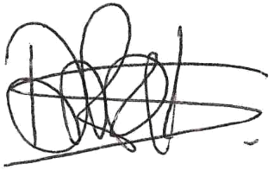
Yours sincerely

Mr Clarke Miss Rock
Deputy Headteacher Head of Year 11

